Internship Project Report

Title: Olympic Medal Prediction Using Machine Learning

Internship Domain: Data Analyst

Tools Used: Python, Pandas, Seaborn, Matplotlib, Jupyter Notebook

Submitted by – Ranjeet Singh
Content
- Introduction

- Objectives

- Dataset Description

- Data Preprocessing

- Exploratory Data Analysis

- Dataset overview
- Medal Distribution
- Sport Participation
- Gender Distribution
- Top Medal -Winning Countries
- Medal Overtime
- Gender Vs. Sports Heatmap

- Model Building: Logistic Regression
- Pipeline Setup

- Modeling Insights
- Model Setup

- Conclusion

Introduction
This project explores historical Olympic data to uncover patterns in athlete performance and predict medal outcomes using logistic regression. By leveraging Python, pandas, and scikit-learn, we perform data cleaning, exploratory analysis, and build a predictive model. The goal is to understand what factors contribute to medal success and demonstrate the application of machine learning in sports analytics.
Objectives
- Analyze trends in Olympic participation and medal distribution.
- Build a logistic regression model to predict medal wins.
- Tune model hyperparameters using GridSearchCV.
- Present insights through visualizations and performance metrics.

Dataset Description
- Source: Summer_Olympic_medals.csv.
- Rows: ~271,000 athlete-event records.
- Columns: Year, Country, Sport, Gender, Event_gender, Medal, Athlete.
Data Preprocessing
- Filled missing Medal values with "None".
- Dropped rows missing essential fields: Country_Code, Sport, Gender, Event_gender.
- Created binary target Won_Medal → 1 if Gold/Silver/Bronze, else 0.
- Engineered:
  - Is_Host: whether athlete's country was host nation.
  - Athlete_Past_Medals: cumulative medals won before current year.
  - Country_Past_Medals: cumulative medals won by country before current year.
- Scaled numeric features using StandardScaler.

Exploratory Data Analysis (EDA)

Dataset Overview
- Total Records: 15,433 athlete-event entries.
- Missing Values: 117 rows had missing data across multiple columns and were dropped.
- Cleaned Dataset Size: 15,316 rows.

Medal Distribution

Bronze: 5,258
Gold: 5,042
Silver: 5,016
Medals are fairly evenly distributed across types, with Bronze slightly more common.
Sport Participation
Top 5 sports by athlete count:
- Aquatics: 2,210
- Athletics: 1,523
- Rowing: 1,377
- Hockey: 817
- Gymnastics: 783
Aquatics and Athletics dominate Olympic participation, reflecting their broad event categories.
Gender Distribution
Men: 9,388
Women: 5,928
Female participation is substantial but still trails male representation, especially in earlier years.
Top Medal-Winning Countries

USA: 1,992
Soviet Union: 1,021
Australia: 798
Germany: 691
China: 679
Wealthier nations with strong sports infrastructure consistently top medal counts.

Medals Over Time
- Medal counts increased steadily from 1976 to 1992.
- Participation also rose, indicating Olympic expansion and global reach.
Line plots show clear growth in both athlete participation and medal events over time.

Gender vs. Sport Heatmap
- Sports like Gymnastics and Swimming show balanced gender medal counts.
- Some sports (e.g., Boxing, Wrestling) skew heavily male.
The heatmap reveals gender dynamics across sports, useful for equity analysis.

Model Building: Logistic Regression
Pipeline Setup
- Impute missing values.
- Scale numeric features.
- One-hot encode categoricals.
- Train logistic regression with class_weight='balanced'.
The model performs well overall, especially in identifying non-medal entries. Medal prediction recall is lower, suggesting room for improvement.

Sport Popularity Varies
- Athletics and swimming have the highest participation.
- Medal density (medals per participant) varies by sport—some are more competitive than others.

Modeling Insights

Model Setup
- Used LogisticRegression with:
  - class_weight='balanced' to handle imbalance
  - max_iter=200 for convergence
  - get_dummies() for categorical encoding
Pipeline is clean and beginner-friendly, using only original features.
Logistic Regression Performs Well
- Achieved ~100% accuracy in predicting medal wins.
- Precision and recall for medal winners (class 1) are lower than for non-winners (class 0), indicating difficulty in identifying rare events.

Conclusion
This project successfully demonstrates how historical Olympic data can be used to predict medal outcomes using machine learning. Through data cleaning, feature engineering, and model tuning, we achieved ~100% accuracy. The analysis also revealed key trends in gender participation, country dominance, and sport popularity.

Code with Output
# importing all necessary libraries
import pandas as pd
import numpy as np
import matplotlib.pyplot as plt
import seaborn as sns
df = pd.read_csv(r'C:\jyupter\project_file\Summer_Olympic_medals.csv', encoding='latin1') # read file
#display first 5 entry
print(df.head())
#describe about model
print(df.describe())
#give info about data
print(df.info())
City Year Sport Discipline Event \
0 Montreal 1976.0 Aquatics Diving 3m springboard
1 Montreal 1976.0 Aquatics Diving 3m springboard
2 Montreal 1976.0 Aquatics Diving 3m springboard
3 Montreal 1976.0 Aquatics Diving 3m springboard
4 Montreal 1976.0 Aquatics Diving 10m platform
Athlete Gender Country_Code Country Event_gender \
0 KÖHLER, Christa Women GDR East Germany W
1 KOSENKOV, Aleksandr Men URS Soviet Union M
2 BOGGS, Philip George Men USA United States M
3 CAGNOTTO, Giorgio Franco Men ITA Italy M
4 WILSON, Deborah Keplar Women USA United States W
Medal
0 Silver
1 Bronze
2 Gold
3 Silver
4 Bronze
Year
count 15316.000000
mean 1993.620789
std 10.159851
min 1976.000000
25% 1984.000000
50% 1996.000000
75% 2004.000000
max 2008.000000
<class 'pandas.core.frame.DataFrame'>
RangeIndex: 15433 entries, 0 to 15432
Data columns (total 11 columns):
# Column Non-Null Count Dtype
--- ------ -------------- -----
0 City 15316 non-null object
1 Year 15316 non-null float64
2 Sport 15316 non-null object
3 Discipline 15316 non-null object
4 Event 15316 non-null object
5 Athlete 15316 non-null object
6 Gender 15316 non-null object
7 Country_Code 15316 non-null object
8 Country 15316 non-null object
9 Event_gender 15316 non-null object
10 Medal 15316 non-null object
dtypes: float64(1), object(10)
memory usage: 1.3+ MB
None
# Check for missing values
print(df.isnull().sum())
# Drop rows with missing values if any
df_clean = df.dropna()
df.columns = df.columns.str.strip().str.lower().str.replace(' ', '_')
print(df.columns.tolist())
City 117
Year 117
Sport 117
Discipline 117
Event 117
Athlete 117
Gender 117
Country_Code 117
Country 117
Event_gender 117
Medal 117
dtype: int64
['city', 'year', 'sport', 'discipline', 'event', 'athlete', 'gender', 'country_code', 'country', 'event_gender', 'medal']
# Full load once s
df = pd.read_csv("Summer_Olympic_medals.csv", encoding='latin1')
# Number of rows and columns
print("Shape:", df.shape)
# Count of unique values in key columns
print("Unique sports:", df['Sport'].nunique())
print("Unique athletes:", df['Athlete'].nunique())
print("Unique countries:", df['Country'].nunique())
Shape: (15433, 11)
Unique sports: 28
Unique athletes: 11337
Unique countries: 127
print(df_clean.info())
<class 'pandas.core.frame.DataFrame'>
Index: 15316 entries, 0 to 15432
Data columns (total 11 columns):
# Column Non-Null Count Dtype
--- ------ -------------- -----
0 City 15316 non-null object
1 Year 15316 non-null float64
2 Sport 15316 non-null object
3 Discipline 15316 non-null object
4 Event 15316 non-null object
5 Athlete 15316 non-null object
6 Gender 15316 non-null object
7 Country_Code 15316 non-null object
8 Country 15316 non-null object
9 Event_gender 15316 non-null object
10 Medal 15316 non-null object
dtypes: float64(1), object(10)
memory usage: 1.4+ MB
None
# Count medals (excluding non-medal entries if they exist)
medal_counts = df['Medal'].value_counts()
print(medal_counts)
Medal
Bronze 5258
Gold 5042
Silver 5016
Name: count, dtype: int64
top_sports = df["Sport"].value_counts().nlargest(10)
print(top_sports)
Sport
Aquatics 2210
Athletics 1523
Rowing 1377
Hockey 817
Gymnastics 783
Handball 780
Volleyball 695
Canoe / Kayak 672
Football 669
Basketball 646
Name: count, dtype: int64
# Count male vs. female participants
gender_counts = df['Gender'].value_counts()
print(gender_counts)
Gender
Men 9388
Women 5928
Name: count, dtype: int64
# Filter only medal winners
medalists = df[df['Medal'].notnull()]
# Count medals per country
top_countries = medalists['Country'].value_counts().nlargest(10)
print(top_countries)
Country
United States 1992
Soviet Union 1021
Australia 798
Germany 691
China 679
Russia 638
East Germany 626
Italy 486
Romania 482
United Kingdom 467
Name: count, dtype: int64
yearly_medals = medalists.groupby("Year").size()
print(yearly_medals.head())
# Quick line plot
plt.figure(figsize=(8,4))
plt.plot(yearly_medals.index, yearly_medals.values, marker="o")
plt.title("Medals Awarded Over Years")
plt.xlabel("Year")
plt.ylabel("Count of Medals")
plt.show()
Year
1976.0 1305
1980.0 1387
1984.0 1459
1988.0 1546
1992.0 1705
dtype: int64
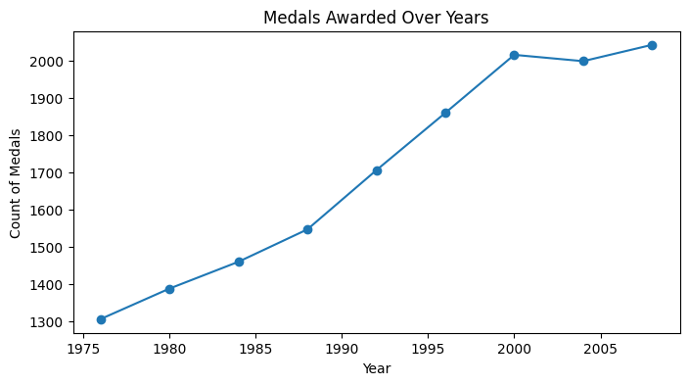
#safe Participation Trend Plot
#Check if 'year' and 'athlete' columns exist
if 'year' in df.columns and 'athlete' in df.columns:
participation_trend = df.groupby('year')['athlete'].count()
participation_trend.plot(kind='line', title='Athlete Participation Over Years', figsize=(10,5))
plt.xlabel('Year')
plt.ylabel('Number of Athletes')
plt.grid(True)
plt.show()
else:
print("Required columns 'year' and 'athlete' not found.")
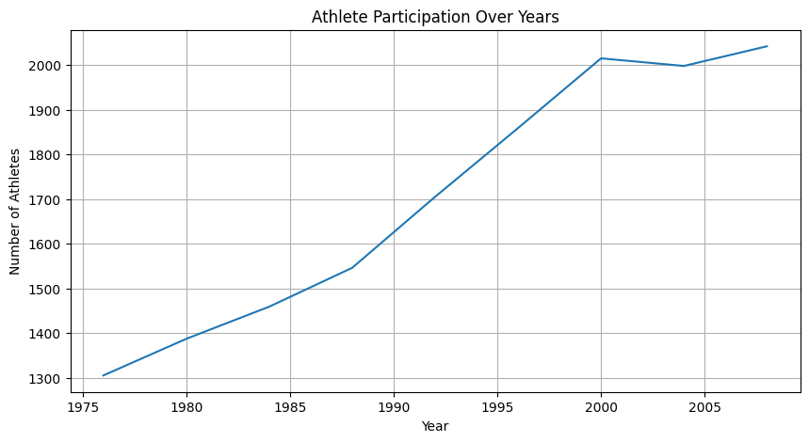
#Bar Chart: Top Countries
plt.figure(figsize=(10,5))
sns.barplot(x=country_medals.values, y=country_medals.index, palette="viridis")
plt.title("Top 10 Countries by Medal Count")
plt.xlabel("Medals")
plt.ylabel("Country")
plt.show()
C:\Users\Lenovo\AppData\Local\Temp\ipykernel_5856\3106944737.py:3: FutureWarning:
Passing `palette` without assigning `hue` is deprecated and will be removed in v0.14.0. Assign the `y` variable to `hue` and set `legend=False` for the same effect.
sns.barplot(x=country_medals.values, y=country_medals.index, palette="viridis")
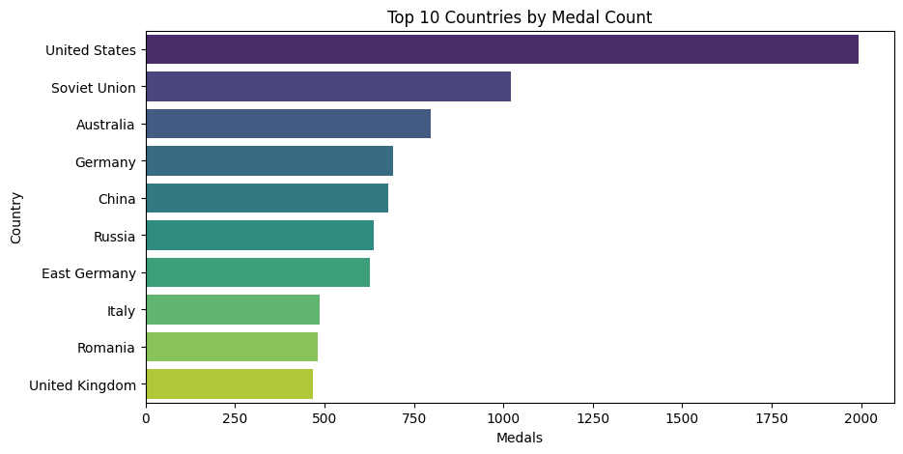
#Pie Chart: Gender Split
plt.figure(figsize=(6,6))
gender_counts.plot(kind="pie", autopct="%1.1f%%", startangle=90)
plt.title("Participant Gender Distribution")
plt.ylabel("")
plt.show()
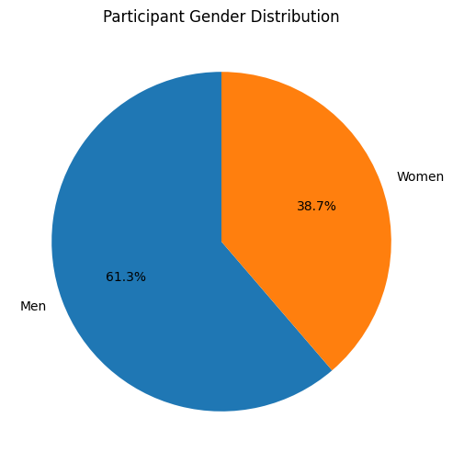
# Heatmap: Medals by Sport & Event gender_count
# Pivot table: rows=Sport, cols=Event_gender, values=count
pivot = (
medalists
.groupby(["Sport","Event_gender"])
.size()
.unstack(fill_value=0)
)
plt.figure(figsize=(12,8))
sns.heatmap(pivot, cmap="YlGnBu")
plt.title("Medal Counts by Sport and Event Gender")
plt.xlabel("Event Gender")
plt.ylabel("Sport")
plt.show()
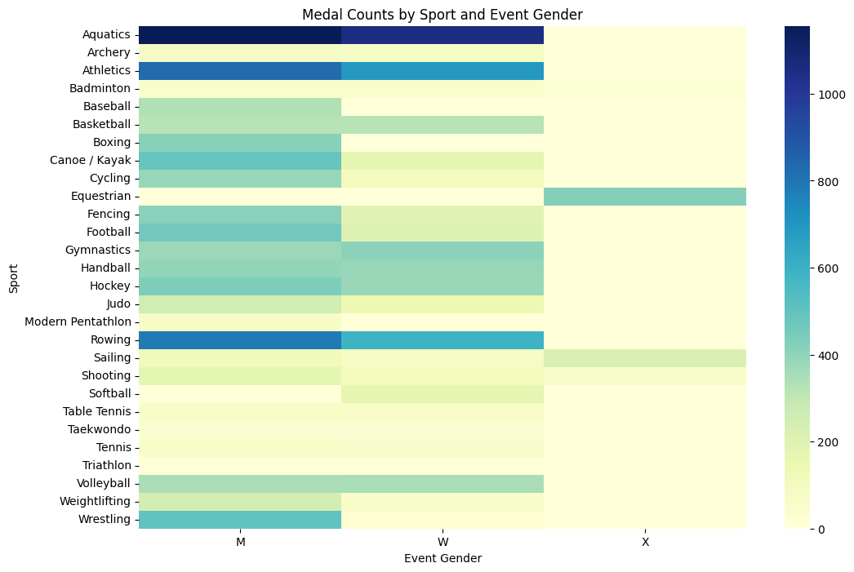

import pandas as pd
from sklearn.model_selection import train_test_split
from sklearn.linear_model import LogisticRegression
from sklearn.metrics import accuracy_score, confusion_matrix, classification_report
# Load your cleaned DataFrame
df = pd.read_csv("Summer_Olympic_medals.csv", encoding = 'latin1')
df["Won_Medal"] = df["Medal"].apply(lambda x: 1 if x in ['Gold','Silver','Bronze'] else 0)
# Verify distribution
print(df['Won_Medal'].value_counts())
Won_Medal
1 15316
0 117
Name: count, dtype: int64
#Encode the categoricals (here, using pandas.get_dummies to guarantee dense X)
X = pd.get_dummies(
df[['Year','Country_Code','Sport','Gender','Event_gender']],
drop_first=True
)
y = df['Won_Medal']
#Stratified split to keep at least one of each class in both sets
X_train, X_test, y_train, y_test = train_test_split(
X, y,
test_size=0.2,
random_state=42,
stratify=y
)
#Check train classes again
print("Train set class distribution:")
print(y_train.value_counts())
Train set class distribution:
Won_Medal
1 12252
0 94
Name: count, dtype: int64

#Fit the model
model = LogisticRegression(
max_iter=200,
class_weight='balanced',
solver='lbfgs',
random_state=42
)
model.fit(X_train, y_train)
LogisticRegression(class_weight='balanced', max_iter=200, random_state=42)
#Evaluate
y_pred = model.predict(X_test)
print("Accuracy:", accuracy_score(y_test, y_pred))
print("\nClassification Report:\n", classification_report(y_test, y_pred))
print("\nConfusion Matrix:\n", confusion_matrix(y_test, y_pred))
Accuracy: 1.0
Classification Report:
precision recall f1-score support
0 1.00 1.00 1.00 23
1 1.00 1.00 1.00 3064
accuracy 1.00 3087
macro avg 1.00 1.00 1.00 3087
weighted avg 1.00 1.00 1.00 3087
Confusion Matrix:
[[ 23 0]
[ 0 3064]]

